SENTIMENT ANALYSIS OF MOROCCAN DIALECT USING TF-IDF
Saloua EL HODIFI¹, Oxy Marcelle MAGNIMA KOUMBA² ,Salma SARHI³ , Kholoud BOULAICH ⁴
¹²³⁴ Abdelmalek Essadi University, Data Science for Economic and Finance Master’s, Tanger
Dr. Mohamed BEN AHMED,Department of computer Science
Abstract. These last years, we observe explosion of technologies like Siri, Alexa or one of the most popular ChatGPT.But, it will be pretty interesting if we try to capture the mechanism behind them. Effectively, the similarity between these tools is the concept of NLP.NLP stands for Natural Language Processing, it is a convergence of artificial intelligence and computational linguistics, which handles interactions between machines and natural languages of humans in which computers are entailed to analyze, understand, alter, or generate natural language. Among the applications of NLP, we have Sentiment Analysis. This process is used for analyzing digital text and return its polarity, i.e. the emotional tone of a given text, either positive, negative or neutral. The latter is very useful for companies or businesses; in the case of digital marketing and so one. However; it is sometimes very hard to analyze messages expressed in some languages; for example; in our case; Moroccan dialect because of its complex morphology. For dealing with, we proposed an approach based on TF-IDF for feature extraction ; as well as some specific libraries for handling one of the main step of sentiment analysis; notably preprocessing. In this paper; we tried to perform the most important steps of SA, firstly preprocessing, secondly feature extraction and finally we applied some classification algorithms from Machine learning.
Keywords: Sentiment Analysis, TF-IDF, Feature extraction, Machine learning, Moroccan dialect.
- Introduction
Currently, social media are really increasing in the daily life. It is a way for freely expressing our opinions about so many things or thematics.And those opinions represent a goldmine for businesses in particular, because by having a review from a client on any product proposed, it will help managers to decision making. Justly, Sentiment analysis can perform this task. By retrieving precious insights from messages, carrying out some actions for making data useful and finally knowing the polarity of texts, Sentiment Analysis became unavoidable for any industry who wants to stay ahead of their competitors. Nevertheless, when it comes to deal with some unstructured languages like Moroccan dialect; it becomes very difficult. Because of that, we proposed to effect feature extraction with TF-IDF, which can allow us to achieve the application of machine learning models like SVM or logistic regression for better classifying the sentiments.
The remaining paper is structured as: section 2 present some challenges encountered in the case of Moroccan Dialect sentiment analysis, section 3 refers to our methodology, Section 4 is about the application of classification algorithms, Section 5 shows the metrics used for evaluating our models, Section 6 highlights our results and a comparative study to another research and finally we conclude in Section 7.
- Sentiment Analysis in Moroccan dialect
Moroccan dialect is also known as darija.It can vary from region to region and there is no standard written form of the dialect. Also, darija is frequently expressed joined to other languages like English, French or Spanish, it can even written in many languages like Arabic, Latin or Arabizi,thus it becomes laborious to analyze the texts and makes obligated to translate and normalize in one only language.
Another hindrance is the normalized Arabic letters like ؤ، ىء Hamza, أ، اAlef or ال، أل lamalef
and the numbers presented in the orthographic darija like in Mer7ba=welcome or fer7an=happy.
And we can note finally and unfortunately the lack of specific resources to darija or the difficulty for finding the data to analyze.
- Proposed Approach
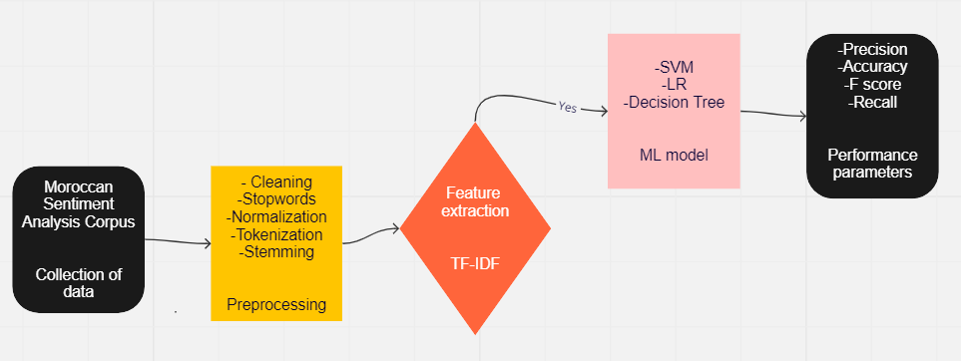
In this section, we unveil the different steps for carrying out our sentiment analysis. We displayed in the following image an overview.
Figure 1: Methodology
  - Dataset
Normally, concerning this work, we were supposed to use the Moroccan Sentiment Twitter Dataset (MSTD), but the github page for accessing to this dataset wasn’t available. Thus, we retrieved a dataset which is a collection of tweets, from another github page, and the latter is called Moroccan Sentiment Analysis Corpus. It is annotated and has two classes of sentiment: positive and negative.
  - Preprocessing Techniques
Because Garbage in equals Garbage out, it is extremely crucial to perform well the preprocessing task, in particular in the case of this language. For dealing with, we followed this architecture described below.

Firstly, we started by cleaning the dataset. We removed anything which hasn’t many importance for the analysis and the prediction of the polarity, like special characters, diacritics, repeated characters, numbers, punctuation and also emoji.

Secondly, we have sometimes some words which are common in any language, like prepositions, conjunctions or pronouns, but doesn’t add much information to the text, they are known as stop words. We removed them by using the NLTK library which contains a built-in stop words.

Thirdly, we tackled the normalization task. Some opinions are written in non-standard ways, e.g., some words contain repeated characters such as “مبرووووووووك ” instead of “مبروك”, which means congratulations, emotions such as “ههههههه” which indicate laughing, and include common spelling mistakes and/or dialects. Normalization step helps to making those texts conform to the standard way.

Fourthly, we performed the tokenization task. It aims to divide the text into pieces of data called tokens. Those tokens contain the essential information important for the analysis.

Finally, we ended by stemming task. The stemming process is used to change different tenses of words to its base form, this process is thus helpful to remove unwanted computation of words. For doing this, we applied a stemming technique called Light Stemming by using a specific library called Tashaphyne.
  - Feature Extraction
Feature Extraction is one of the most important steps to be followed for a better understanding of the context of what we are dealing with. After the initial text is cleaned, we need to transform it into its features to be used for modeling. In other terms, we have to perform feature extraction from the raw text in order to pass numerical features to machine learning algorithms.
For doing this, we choose TF-IDF which stands for Term Frequency Inverse Document Frequency.
TF-IDF, is a commonly used technique in NLP to determine the significance of words in a document or corpus. Essentially, it measures the importance of a word by comparing its frequency within a specific document with the frequency to its frequency in the entire corpus. The underlying assumption is that a word that occurs more frequently within a document but rarely in the corpus is particularly important in that document.
- Classification Algorithms
Here, we show the ML model used for classifying our reviews based on their sentiments.
  - Logistic Regression
Logistic regression is a process of modeling the probability of a discrete outcome given an input variable. The most common logistic regression models a binary outcome; something that can take two values such as true/false, yes/no, and so on. This algorithm is also called Maximum Entropy.
  - Support Vector Machine
Support Vector Machine is a supervised algorithm used for both regression and classification tasks. Its objective is to find a hyperplane in an N-dimensional space (N — the number of features) that distinctly classifies the data points.
  - Decision Tree
This algorithm is very efficient by the way whose it works. The core idea is to divide the dataset into smaller subsets and at the same time tree associated is incrementally created. This can handle both categorical as well numerical data.
- Performance Parameters
In this party, we expose the metrics used for judging or estimating the quality of our ML models.
  - Accuracy
This is the ratio of true positives plus true negative to the true positives plus true negatives plus false positive plus false negative as shown in equation 1 or better in 1.a. It calculates how much percentage of cases is correctly classified.
$Accuracy=\frac{(True positive+True negative)}{True positive+True negative+False positive+False negative}$ ………… (1)

$Accuracy=\frac{Number of correct predictions}{Total number of predictions}$ ………… (1.a)
  - Precision
Precision attempts to answer the following question:

What proportion of positive identifications was actually correct?
Ratio of predicted positive observations to the total number of positive observation is known as precision. It is computed as follows:
$Precision=\frac{True positive}{True positive+False positive}$………….. (2)

$Precision=\frac{Relevant retrieved instances}{All retrieved instances}$ …………… (2.a)
  - Recall
Ratio of correctly predicted positive observations to all observations in actual class yes is known as recall. It is computed as follows:
$Recall=\frac{True positive}{True positive+False negative}$ ………… (3)

$Recall=\frac{Relevant retrieved instances}{All relevant instances}$ …………. (3.a)

  - F-1score
Weighted average of recall and precision is called f-score. More important parameter than accuracy when having an uneven class distribution in data. It is calculated as follows:
$F-score=\frac{2*Precision*Recall}{Precision+Recall}$ ……(4)
- Results and Comparison analysis
  - Results of the work
Within the scope of this work, we wanted to approach the Moroccan dialect sentiment analysis by performing the features extraction step using Term Frequency Inverse
Document Frequency (TF-IDF).Then we applied three machine learning algorithms for classification, especially Support Vector Machine, Logistic Regression and Decision Tree. We partitioned the data into training and testing using the 80-20 method. Finally, we evaluated the performance of our models based on Accuracy, Precision, Recall and F-1 score metrics.

 | SVM | LR | DT
Precision | Neg:81%  Pos:81% | Neg:80%  Pos:81% | Neg:83%  Pos:61%
Recall | Neg:85%  Pos: 76% | Neg85:%  Pos:74% | Neg:53%  Pos:87%
F-1 score | Neg:83%  Pos: 78% | Neg:82%  Pos:77% | Neg:64%  Pos:71%
Accuracy | 81% | 80% | 68%

Table 1: Classification Results

We can notice that the performance of a model can vary depending on the metric, but the gap between the results are not so huge.
  - Comparison analysis
In this section, we conduct a mini comparative study between our work and a research leaded on the similar object, but through Word embedding using Arabert for features extraction and some deep learning models for classification.

Firstly, it’s necessary to precise that we didn’t use the same dataset. The authors used the MSTD whose the size is bigger than ours. MSTD is a collection of 12K Moroccan tweets that were annotated with four separate classes: 2769 negative, 866 positives, 6378 objective, and 2188 sarcasm whereas our dataset has only two classes: positive and negative.

Secondly, there are many differences between TF-IDF and Word embedding showed in the following image.
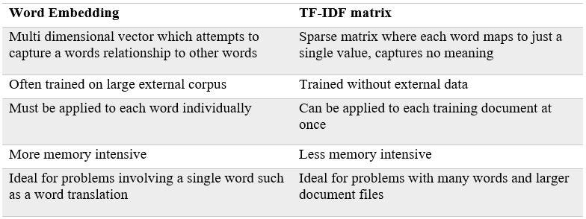
Table 2: TF-IDF vs Word Embedding

We can note that according to the differences, Word embedding is better than TF-IDF and can have best results for making relevant classification by ML models.

Finally, we displayed the difference between the performance of our models and their models based on Accuracy metric.

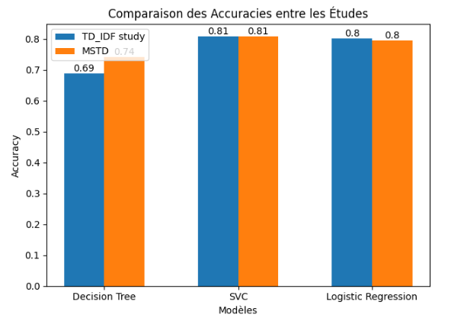
Figure 2: Performance based on accuracy

- Conclusion
The object of this work was to propose an approach to Moroccan Dialect sentiment analysis. And for doing that, we retrieved a dataset from a github page and preprocessed it by performing cleaning, stop words removal, normalization, tokenization and finally stemming.Then,we built some ML models for helping us to classify the sentiments of the tweets; there were Support Vector Machine ,Logistic Regression and Decision Tree. Finally; we evaluated the performance of our models base on Accuracy Precision Recall and F score metrics.
Considering that sentiment analysis becomes more important, it will interesting to lead a future research with other tools like Arabert and Deep learning models like Long Short Term Memory or Neural Network.

References
- The International Conference on Digital Age & Technological Advances for sustainable
Development: ‘Sentiment Analysis through Word embedding using AraBERT: Moroccan Dialect use case’’, ©2021.
- Ravinder Ahuja, Aakarsha Chug,Shruti Kohli,Shaurya Gupta, and Pratyush Ahuja:’’The impact of Features extraction on the sentiment analysis’’, International Conference on
Pervasive Computing Advances and Applications – PerCAA 2019.
- Mouaad Errami, Mohamed Amine Ouassil, Rabia Rachidi, Bouchaib Cherradi, Soufiane Hamida, Abdelhadi Raihani: ‘’ Sentiment Analysis on Moroccan Dialect based on
ML and Social Media Content Detection’’, (IJACSA) International Journal of Advanced Computer Science and Applications,Vol. 14, No. 3, 2023.
- Soukaina MIH1, Brahim AIT BEN ALI , Ismail EL BAZI , Sara AREZKI , Nabil LAACHFOUBI.: ‘’ MSTD: Moroccan Sentiment Twitter Dataset’’, (IJACSA) International Journal of Advanced Computer Science and Applications, Vol. 11, No. 10, 2020.
- MOUHOUBI Azzedine,GHEFFARI Mohammed Abdelfattah,’’Analyse de sentiments dans la langue arabe en utilisant differentes approches’’,presente en vue de l’obtention du diplome de Master,2019-2020.
- EL BERGUI Adam :’’Sentiment Analysis for Moroccan Dialect’’,September 2019

https://towardsdatascience.com/how-amazon-alexa-works-your-guide-to-natural-language-processing-ai-7506004709d3
https://raw.githubusercontent.com/ososs/Arabic-Sentiment-Analysis-corpus/master/MSAC.arff
https://towardsdatascience.com/understanding-tf-idf-a-traditional-approach-to-feature-extraction-in-nlp-a5bfbe04723f

